Problem 1: Lexical Analysis – Token Density Indicator
(HoT ASSIGNMENT)

NAME : K HARIGARAN
REG NO: RA2311026050281
BRANCH: CSE / AIML A
COURSE: COMPILER DESIGN

1. Problem Understanding
In compiler design, lexical analysis is the first phase where source code is broken into small units called tokens (keywords, identifiers, operators, symbols, etc.).
When a source file has too many tokens packed into very few lines, it becomes difficult to read and maintain. This metric is called Token Density.
Formula:
Token Density = Total Tokens ÷ Total Lines
If the density is too high, it indicates complex, unreadable code — flagged as Is_Token_Heavy = YES.

2. Logic Used
Step 1 – Data Preparation: Sample data of 5 source files is created with their token counts and line counts using a Python dictionary loaded into a Pandas DataFrame.
Step 2 – Feature Computation: A new column Token_Density is computed by dividing Token_Count by Line_Count for each file.
Token_Density = Token_Count / Line_Count

Step 3 – Flag Generation: A threshold of 5.0 is defined. Using a lambda function with .apply(), each file is checked:
If Token_Density > 5.0 → Is_Token_Heavy = YES
Else → Is_Token_Heavy = NO
Step 4 – Output Display: The final DataFrame is printed clearly showing all computed features and flags.

Step 4 – Output Display

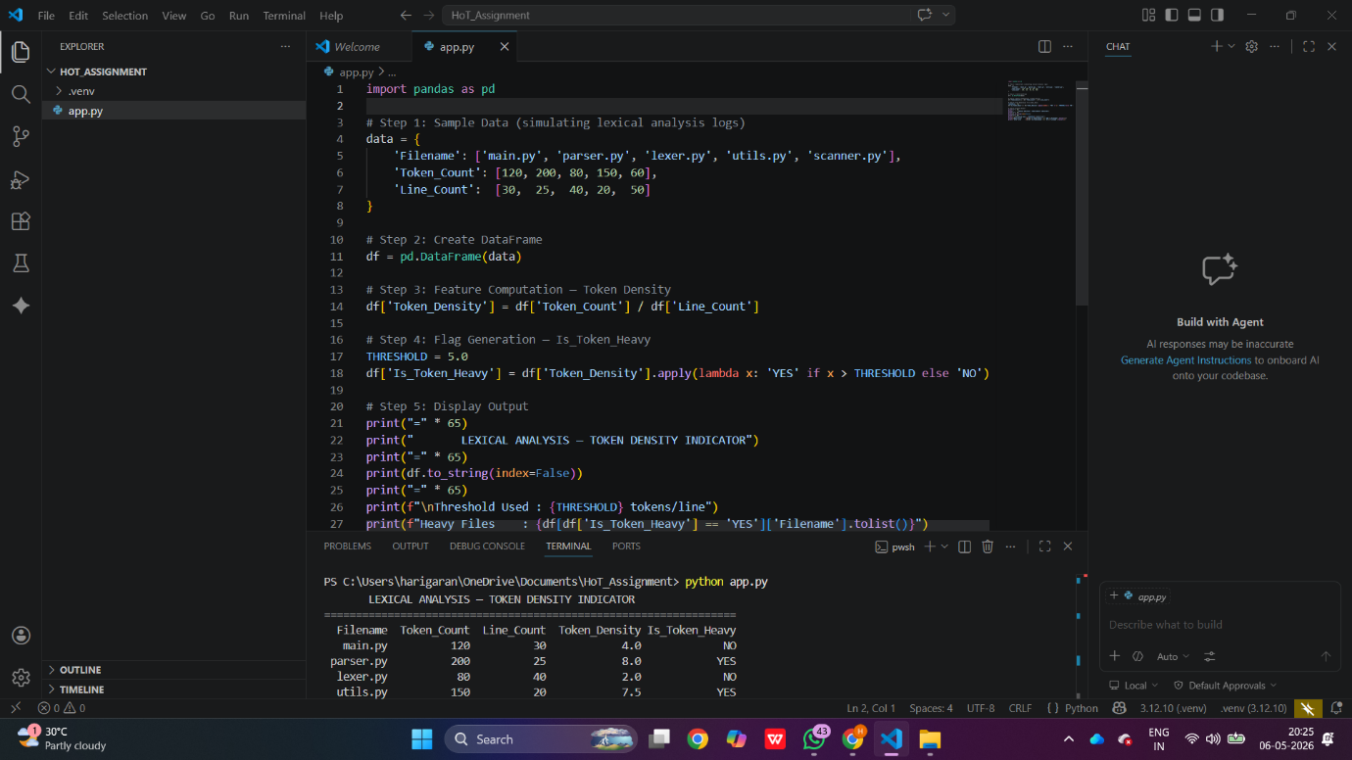

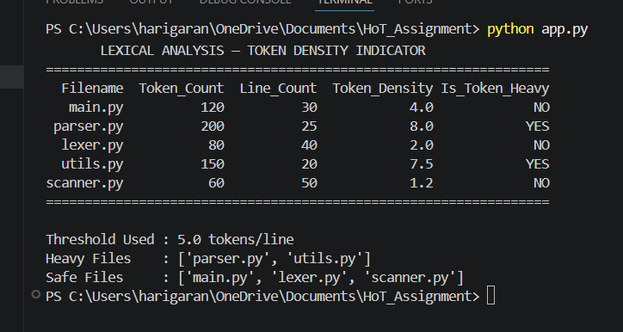

3. Output Summary
File | Tokens | Lines | Density | Is_Token_Heavy
main.py | 120 | 30 | 4.00 | NO
parser.py | 200 | 25 | 8.00 | YES
lexer.py | 80 | 40 | 2.00 | NO
utils.py | 150 | 20 | 7.50 | YES
scanner.py | 60 | 50 | 1.20 | NO

4. Justification of Threshold
A threshold of 5.0 tokens per line is chosen because:
- Industry-standard readable code typically contains 3 to 5 tokens per line
- Beyond 5.0, lines tend to have nested expressions or multiple operations which reduce readability
- Files like parser.py (8.00) and utils.py (7.50) clearly exceed this, indicating they need refactoring or code splitting
- This threshold aligns with software maintainability standards used in real compiler development teams

5. Tools Used

Tool | Purpose
Python 3.12 | Programming language
Pandas Library | DataFrame creation, feature computation, flag generation
VS Code | Development environment

